Septa

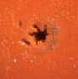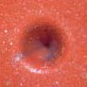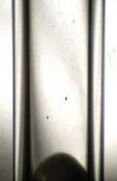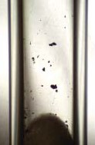Premium Septa

Septum Without CenterGuide

Septum With CenterGuide
Premium Septa are preconditioned and packed in glass jars. Premium septa generally have much lower bleed than general purpose septa.

CenterGuide™ Septa for Improved Performance
• Center point guides the needle for easy penetration
• Reduce needle bending
• Precision molding assures accurate fit
• Available in selected sizes of our premium septa

Precision-molded septa have a recess on the injection side, to guide the syringe needle to the same point with every injection. The CenterGuide design requires less force for initial penetration, for a smoother feel. Septum life may be enhanced in some applications by minimizing tearing and coring.

High
Pre-
Low
Suggested

Septum Temperature pierced Bleed Applications

Marathon™ ✓ BTO® ✓ Advanced Green 3™ ✓

Autosampler use; pre-pierced greater reliability, trace analysis
✓ •

High injection port temperature, lowest bleed, trace analysis
• ✓

• • General purpose use; low sticking

Upper Temperature Limit: Septa BTO, Marathon and Advanced Green 3 can be used at
400°C and injector set point temperatures in most instruments. Slight sticking may occur in new injection ports when holding septa above 300°C over many days.

CenterGuide can help reduce coring when used with tapered (rounded-tip) needles.

46 Chromatography Research Supplies

Septa Cross Reference

Instrument Septum Size
Agilent/HP
5880A, 5890, 6850, 6890, 7890, 7890A , & 7820A 11 mm
5700 series, 5830/40 9.5 mm On-column injection 5 mm Purged packed column 11 mm

Fisons/Carlo Erba
8000 Series 17 mm

PerkinElmer
Sigma Series, 8000 Series, Clarus 11 mm
AutoSystem/AutoSystem XL 11 mm

Shimadzu
9A, 14, 15A, 16, 17A, 2010 & 2014 Plug

Thermo Instruments
Trace, Focus Split/Splitless, 8000 Series 17 mm
9001, GCQ 9 mm
PTV Injector 12.7 mm

Varian
1177 Injector 9 mm
1040/41/60/61 9.5 mm
1075/77/78, 1079, 1093/94 SPI 11.5 mm

Measuring Chart

5 mm / 3/16”

7 mm / 9/32”

9 mm / 11/32”

9.5 mm / 3/8”

10 mm / 13/32”

11 mm / 7/16”

12.5 mm / 1/2”

17 mm / 21/32”

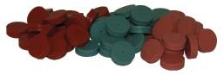

www.chromres.com 47

Septa

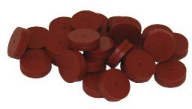Septa BTO®

BTO 11mm Septa
• Extended temperature range, low-bleed
• Maximum temperature 400°C*
• Virtually eliminates injection-port sticking
• Pre-conditioned; packaged in glass to prevent contamination
• Each batch GC-FID tested
• Ideal for use with low-bleed, “Mass Spec” capillary columns

Septa BTO is Bleed and Temperature Optimized for today’s most demanding GC and GC/ MS applications. Septa BTO is formulated to extend low-bleed and outstanding mechanical properties of premium GC septa to the highest-temperature applications. It retains remark- able softness and pierceability at high temperatures, with extremely low bleed. Septa are
3 mm thick, except Shimadzu-style plug septa, and are packaged in glass vials.

 | Description | Qty | Item No.
 | 5 mm BTO CenterGuide™ | 50/pk | 298787
 | 1/4” (6.4 mm) BTO | 50/pk | 298755
 | 9 mm BTO CenterGuide | 50/pk | 298713
 | 3/8” (9.5 mm) BTO | 50/pk | 298705
 | 10 mm BTO | 50/pk | 298745
 | 7/16” (11 mm) BTO CenterGuide | 50/pk | 298717
 | 7/16” (11 mm) BTO CenterGuide | 100/pk | 298718
 | 11.5 mm BTO CenterGuide | 50/pk | 298777
 | 1/2” (12.7 mm) BTO CenterGuide | 50/pk | 298727
 | 17 mm BTO CenterGuide* | 50/pk | 298817
 | BTO for Shimadzu | 50/pk | 298735
 | * For 17mm injectors the maximum is 300°C

48 Chromatography Research Supplies

Advanced Green 3™

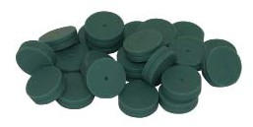• True low-bleed, high temperature green septum
• Maximum temperature 400°C

The CRS Advanced Green 3 Septum was specifically created to combine significantly longer injection life, low bleed and low injection port adhesion. The result is a green septum you can use for all your critical analyses. Advanced Green 3 Septa are packaged in glass vials for
high purity. Septa are 3 mm thick, except Shimadzu-style plug septa.

AG3 11mm Septa

 | Description | Qty | Item No.
 | 5 mm AG3 CenterGuide | 50/pk | 246525
 | 9 mm AG3 CenterGuide | 50/pk | 246713
 | 3/8” (9.5 mm) AG3 | 50/pk | 246124
 | 7/16” (11 mm) AG3 CenterGuide | 50/pk | 246225
 | 7/16” (11 mm) AG3 CenterGuide | 100/pk | 246228
 | 11.5 mm AG3 CenterGuide | 50/pk | 246725
 | 1/2” (12.7 mm) AG3 CenterGuide | 50/pk | 246325
 | 17 mm AG3 CenterGuide | 50/pk | 246624
 | AG3 for Shimadzu | 50/pk | 246424

Marathon™ Septa

• Excellent Performance with Long Injection Life
• Pre-pierced for greater reliability
• Premium septum for autosamplers
• CenterGuide™ Marathon are pre-pierced for extremely reliable performance
• Maximum temperature setting 400°C

The CenterGuide versions of Marathon are pre-pierced to channel the needle through the same spot with each injection, which helps eliminate the common type of coring that occurs on the first injection. The Marathon septum is also ideal for standard manual-injection GC and GC/MS. Septa are 3 mm thick, except Shimadzu-style plug septa. Septa are packaged in glass jars.

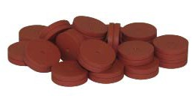Marathon 11mm Septa

 | Description | 25/pk | 50/pk | 100/pk
 | 5 mm Marathon CenterGuide | 239587 | 239597
 | 9 mm Marathon CenterGuide | 239778 | 239779
 | 7/16” (11 mm) Marathon CenterGuide | 239287 | 239297 | 239888
 | 11.5 mm Marathon CenterGuide | 239787 | 239798
 | 1/2” (12.7 mm) Marathon CenterGuide | 239387 | 239397
 | 17 mm Marathon | 239688 | 239698
 | Shimadzu | 239488 | 239498

www.chromres.com 49

Septa

Puresep T™
General-Purpose Septa

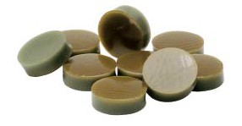Puresep T

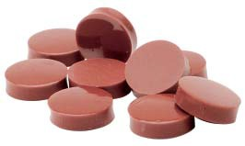Puresep P

• The better PTFE coated septum
• Recommended maximum temperature is 225°C

Silicone-based septum is faced on one side with a double layer of polyimide and PTFE. The polyimide adheres to both the silicone and PTFE, providing a better bond and enhanced durability. The outer PTFE coating assures maximum inertness and helps minimize bleed.

Description Qty Item No.
1/4” (6.0 mm) Puresep T 50/pk 230665
3/8” (9.5 mm) Puresep T 50/pk 230675
7/16” (11 mm) Puresep T 50/pk 230685
11.5 mm Puresep T 50/pk 230697
1/2” (12.7 mm) Puresep T 50/pk 230695
13 mm Puresep T 50/pk 230698

Puresep P™

• Made from silicone rubber coated with a layer of high-temperature polyimide
• 3 mm thick

The polyimide layer is stable to 400°C, however the recommended upper limit for the septum as a whole is 300°C, due to the characteristics of silicone.
 | Description | Qty | Item No.
 | 1/4” (6.0 mm) Puresep P | 50/pk | 230630
 | 3/8” (9.5 mm) Puresep P | 50/pk | 230640
 | 7/16” (11 mm) Puresep P | 50/pk | 230650
 | 11.5 mm Puresep P | 50/pk | 230670
 | 1/2” (12.7 mm) Puresep P | 50/pk | 230660
 | 13 mm Puresep P | 50/pk | 230680

50 Chromatography Research Supplies

Economy Blue Septa

Our Blue Septa are designed for non-demanding, routine applications. They are easy to penetrate, with a durometer rating of 40 - 45. The septa can be used up to 250°C and are suitable for 90% of all GC analyses. Made from silicone.

Description Qty Item No.
1/4” (6.4 mm) Economy Blue Septa 100/pk 234625
3/8” (9.5 mm) Economy Blue Septa 100/pk 234905
7/16” (11 mm) Economy Blue Septa 100/pk 234115
1/2” (12.7 mm) Economy Blue Septa 100/pk 234125

Accessories

Injection Port Cleaning Kit

This is designed for cleaning all GC injection ports, including those in Shimadzu instruments. Included are three stainless steel brushes, 5 mm (for Shimadzu), 1/4” and 3/8”, and one scraper for removing septum residue.

Description Item No. Injection Port Cleaning Kit 206211

Septa Pick

The Septa Pick is useful for removing small pieces of septa lodged in the threads and corners of the septum cap or injection port. It can also be used to remove small bits of graphite ferrule from the cap and fittings of column connectors; other small cleaning jobs.
Description Item No. Septa Pick 205465

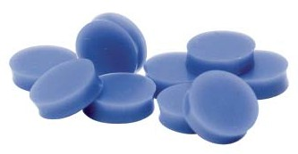Economy Blue Septa

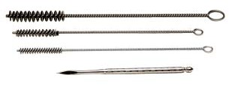206211

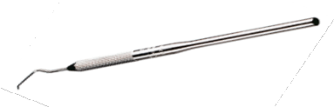205465

www.chromres.com 51

