Ferrules

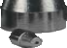CRS provides a wide range of ferrules made from Vespel®, Vespel/Graphite, Graphite and PTFE. Ferrule sizes refer to the size of the fittings into which they fit; they are not the diameter of the ferrule. For example, 1/16” ferrules are 1/8” diameter and fit in 1/16” fittings.

Graphite Ferrules - Sold in packages of 10; except as noted

Graphite Ferrules

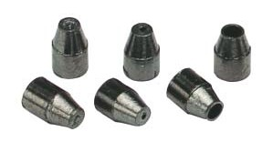1/16” Graphite Ferrules: Blank, 0.5mm ID, Straight

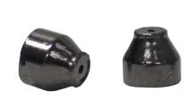211165
• Upper temperature limit: 450°C
Description Item No. Straight Ferrules - for tubing with ODs listed
1/16” Ferrules 211100
1/8” Ferrules 211200
1/4” Ferrules 211400
3/8” Ferrules 211600
1/2” Ferrules, 5/pk 211800
3/4” Ferrules, 5/pk 211120

Blank Ferrules - no holes
1/16” Blank Ferrules 2111XX
1/8” Blank Ferrules 2112XX
1/4” Blank Ferrules 2114XX

Capillary Column Ferrules For Capillary Sizes - ID
1/16” to 0.4 mm 0.25 mm 211104
1/16” to 0.5 mm 0.32 mm 211105
1/16” to 0.8 mm 0.53 mm 211108
1/16” to 1.0 mm 0.65 mm 211110
1/16” to 1.2 mm 0.75 mm 211112
1/16”, two-hole, 0.5 mm each 0.32 mm 211125

Short Ferrules for Agilent Inlets*
1/16” to 0.4 mm 0.18 mm 211164
1/16” to 0.5 mm 0.25 - 0.32 mm 211165
1/16” to 0.8 mm 0.53 mm 211168
1/16” to 1.0 mm 0.53 - 0.65 mm 211160

For Tubing (Fitting Size to Tubing OD)
1/16” to 1/16” straight ferrule 1/16” 211170
*Short ferrule for Agilent inlet systems: 5890, 6890 and 7890.

12 Chromatography Research Supplies

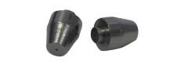211205
Reducing Ferrules  1/8” to 0.4 mm | For Capillary Sizes - ID  0.25 mm | 211204
1/8” to 0.5 mm | 0.32 mm | 211205
1/8” to 0.8 mm | 0.53 mm | 211208
1/8”, two-hole, 0.5 mm each | 0.32 mm | 211222
1/4” to 0.5 mm | 0.32 mm | 211405
1/4” to 0.8 mm | 0.53 mm | 211408
 | For Tubing Sizes - OD
1/8” to 1/16” | 1/16” | 211210
1/4” to 4 mm | 4 mm | 211440
1/4” to 6 mm | 6 mm | 211406
1/4” to 1/16” | 1/16” | 211410
1/4” to 1/8” | 1/8” | 211420
Shimadzu Ferrules
5 mm, Shimadzu 5 mm OD columns |  | 211500
Capillary Column Ferrules | For Capillary Sizes - ID
Shimadzu 17A, 2010, & 2014 GCs, 0.4mm | 0.25 mm and less | 211174
Shimadzu 17A, 2010, & 2014 GCs, 0.5mm | 0.32 mm | 211175
Shimadzu 17A, 2010, & 2014 GCs, 0.8mm | 0.53 mm | 211178
Thermo Instrument Ferrules
M8 Nut
0.5 mm ID |  | 211905
0.8 mm ID |  | 211908
Cup Ferrules - M4 Nut | For Capillary Sizes - ID
0.28 mm ID |  | 211982-10
0.38 mm ID | 0.25 mm | 211983-10
0.48 mm ID | 0.32 mm | 211984-10
0.80 mm ID | 0.53 mm | 211988-10

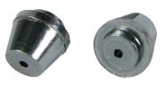211410

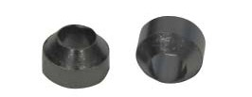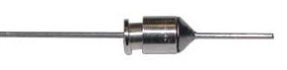211500

211174

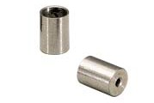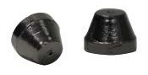211905

211983-10

www.chromres.com 13

Ferrules

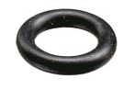216973

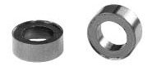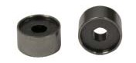216949

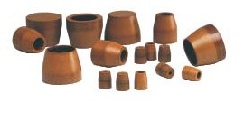216948

Vespel® Ferrules

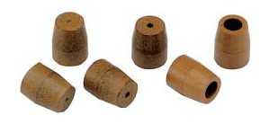1/16” Vespel Ferrules: Blank, 0.5mm ID, Straight
Liner Seals; O-Rings
Graphite and Fluoroelastomer liner seals.
Description Similar Part No. Qty Item No. For Agilent Instruments
Graphite Liner Seal, 6.35 mm ID 5180-4168 10 216635
Graphite Liner Seal, 6.52 mm ID 5180-4173 10 216652
O-ring made of Fluoroelastomer for Agilent 12 216973
Fluoroelastomer O-ring for Agilent 10 216980

For PerkinElmer
Graphite O-Ring each 216637

For Shimadzu Instruments
Graphite Liner Seal 10 211195
Graphite O-Ring, Split 221-48393-91 10 216638
Graphite O-Ring, Splitless 221-47222-91 10 216639

For Thermo Trace GC
5 mm Graphite Seal 2 216949
8 mm Graphite Liner Seal each 216948

For Varian 1078/1079
Graphite Liner Ferrule each 211550

Vespel Ferrules - Sold in packages of 10
• Upper temperature limit: 350°C

Description Item No. Straight Ferrules - for tubing with ODs as listed
1/16” Ferrules 212100
1/8” Ferrules 212200
1/4” Ferrules 212400

Blank Ferrules - no holes
1/16” Blank Ferrules 2121XX
1/8” Blank Ferrules 2122XX
1/4” Blank Ferrules 2124XX

14 Chromatography Research Supplies

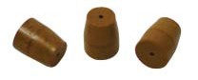212104
Capillary Column Ferrules  1/16” to 0.3 mm | For Capillary Sizes - ID  0.10 - 0.18 mm | 212103
1/16” to 0.4 mm | 0.25 mm | 212104
1/16” to 0.5 mm | 0.32 mm | 212105
1/16” to 0.8 mm | 0.53 mm | 212108
1/16” to 1.0 mm | 0.65 mm | 212110
1/16” to 1.2 mm | 0.75 mm | 212112
1/16”, two-hole, 0.4 mm each | 0.25 mm | 212124
1/16”, two-hole, 0.5 mm each | 0.32 mm | 212125
Short Ferrules for Agilent Inlets*  1/16” to 0.4 mm | 0.25 mm | 212164
1/16” to 0.5 mm | 0.32 mm | 212165
1/16” to 0.8 mm | 0.53 mm | 212168
Reducing Ferrules  1/8” to 0.4 mm | 0.25 mm | 212204
1/8” to 0.5 mm | 0.32 mm | 212205
1/8” to 0.8 mm | 0.53 mm | 212208
1/8”, two-hole, 0.5 mm each | 0.32 mm | 212222
For Tubing (Fitting Size to Tubing OD)  1/8” to 1/16” | 1/16” | 212210
1/4” to 1/16” | 1/16” | 212410
1/4” to 1/8” | 1/8” | 212420

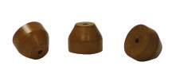212165

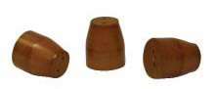212222

*Short ferrules for Agilent inlet systems: 5890, 6890 and 7890.

Please note for all ferrules:
• 0.4 mm ID ferrules fit 0.25 mm ID capillary columns
• 0.5 mm ID ferrules fit 0.32 mm ID capillary columns
• 0.8 mm ID ferrules fit 0.53 mm ID capillary columns
• Straight ferrules are used for packed columns

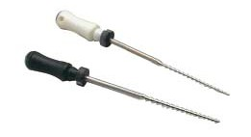Ferrule Remover

These are effective tools for removing ferrules. The threaded end locks in the ferrule hole to allow a good grip. Two tools are supplied for ferrules from 0.4 mm to 0.8 mm ID.

Description Item No. Ferrule Remover 205315

205315

www.chromres.com 15

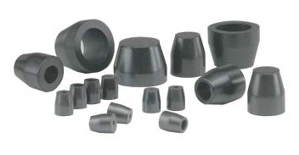Ferrules

Vespel/Graphite Ferrules

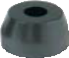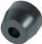
213200

Vespel®/Graphite Ferrules - Sold in packages of 10; except as noted
• Upper temperature limit: 400°C
• Precision drilled ID

Description Item No. Straight Ferrules - for tubing with ODs as listed
1/16” Ferrules 213100

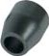
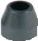213105
1/8” Ferrules |  | 213200
1/4” Ferrules |  | 213400
1/2” Ferrules, 5/pk |  | 213800
Blank Ferrules - no holes  1/16” Blank Ferrules |  | 2131XX
1/8” Blank Ferrules |  | 2132XX
1/4” Blank Ferrules |  | 2134XX
Capillary Column Ferrules  1/16” to 0.3 mm | For Capillary Size - ID | 213103
1/16” to 0.4 mm | 0.25 mm | 213104
1/16” to 0.5 mm | 0.32 mm | 213105
1/16” to 0.8 mm | 0.53 mm | 213108
1/16” to 1.0 mm | 0.65 mm | 213110
1/16”, two-hole, 0.4 mm each | 0.25 mm | 213124
1/16”, two-hole, 0.5 mm each | 0.32 mm | 213125
Short Ferrules for Agilent Inlets*  1/16” to 0.3 mm | 0.10 mm | 213163
1/16” to 0.4 mm | 0.25 mm | 213164
1/16” to 0.5 mm | 0.32 mm | 213165
1/16” to 0.8 mm | 0.53 mm | 213168
Reducing Ferrules  1/8” to 0.4 mm | 0.25 mm | 213204
1/8” to 0.5 mm | 0.32 mm | 213205
1/8” to 0.8 mm | 0.53 mm | 213208
1/8”, two-hole, 0.5 mm each | 0.32 mm | 213222
1/8”, two-hole, 0.8 mm each | 0.53 mm | 213228
1/4” to 0.4 mm | 0.25 mm | 213404
1/4” to 0.5 mm | 0.32 mm | 213405
1/4” to 0.8 mm | 0.53 mm | 213408

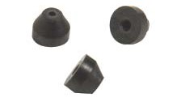213164

16 Chromatography Research Supplies

 | For Tubing Sizes - OD
1/8” to 1/16” | 1/16” | 213210
1/4” to 1/16” | 1/16” | 213410
1/4” to 6 mm | 6 mm | 213406
1/4” to 1/8” | 1/8” | 213420
*Short ferrule for Agilent inlet systems: 5890, 6890 and 7890.

PTFE Ferrules - Sold in packages of 10
• Upper temperature limit: 250°C
• 100% PTFE
Description Item No. Straight Ferrules - for tubing with ODs as listed
1/16” Ferrules 214100

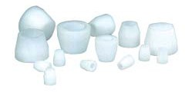PTFE Ferrules

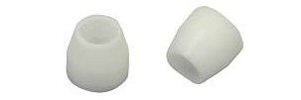214300
1/8” Ferrules |  | 214200
3/16” Ferrules |  | 214300
1/4” Ferrules |  | 214400
Blank Ferrules - no holes  1/16” Blank Ferrules |  | 2141XX
1/8” Blank Ferrules |  | 2142XX
1/4” Blank Ferrules |  | 2144XX
Capillary Column Ferrules  1/16” to 0.3 mm | For Capillary Sizes - OD | 214103
1/16” to 0.4 mm | 0.25 mm | 214104
1/16” to 0.5 mm | 0.32 mm | 214105
1/16” to 0.8 mm | 0.53 mm | 214108
1/16” to 1.0 mm | 0.65 mm | 214110
1/16” to 1.2 mm | 0.75 mm | 214112
Reducing Ferrules  1/8” to 0.4 mm | 0.25 mm | 214204
1/8” to 0.5 mm | 0.32 mm | 214205
1/8” to 0.8 mm | 0.53 mm | 214208
1/8” to 1/16” | For Tubing Sizes - ID  1/16” | 214210
1/4” to 6 mm | 6 mm | 214406
1/4” to 1/16” | 1/16” | 214410
1/4” to 1/8” | 1/8” | 214420
1/4” to 3/16” | 3/16” | 214430

2144XX

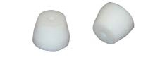214410

www.chromres.com 17

